**The fictional simplicity of Generalized Linear Models**

Who doesn’t love GLMs? The ingenious idea of taking a response level variable (e.g. binary or count) and getting some link function magic to treat it as if it was our long-time friend, linear regression.

In the last few days, a [preprint by McCabe *et al.*](https://doi.org/10.31234/osf.io/th94c) popped up in our twitter feed (recommended reading!) and re-focused our attention on the problem with interpreting effects and interactions within the GLM framework. McCabe *et al.* state in the abstract that:

“To date, typical practice in evaluating interaction effects in GLMs extends directly from linear approaches, in which the product term coefficient between variables of interest are used to provide evidence of an interaction effect. However, unlike linear models, interaction effects in GLMs are not equal to product terms between predictor variables and are instead a function of all predictors of a model.”

The what-now?

When fitting a GLM we think of the response level (the binary outcome or the counts that interest us), however, the model is fit (and often all statistical inferences are done) on the latent level – in the realm of the link function.

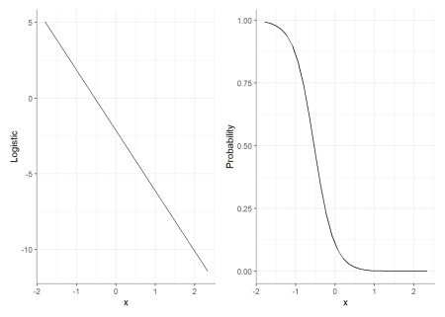

For interactions (but as you will see soon, not only), it means that when we test the effect of X1 at different levels of X2, we’re testing these effects **on the latent (e.g., logistic) level, which might not represent these effects on the response level!**

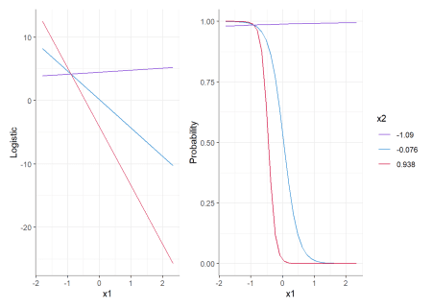

For example, both plots above represent corresponding predictions from the same interaction-model – on the left we have those predictions on the latent level, and on the right these have been transformed back to the response level (the probability). We can see that at the latent level, the effect of X1 on y is very different at all levels of X2, but at the response level these differences can shrink or possibly disappear (e.g., red vs. blue lines), or get larger (red and blue vs. purple line).

This is true regardless of whether or not an interaction was included in the model! And in fact, even main effects on the latent level do not always correspond to the response level the way we would have intuitively imagined.

What follows are 3 methods for testing interactions in GLMs, using emmeans. Again, we highly recommend reading McCabe *et al.*’s original paper.

Let’s load up some packages:

library(emmeans) # 1.4.5

library(magrittr) # 1.5

**The Model**

The model used here is a logistic regression model, except we’re using a binomial outcome (see code for data generation at the end of the post):

y <- plogis(xb) < 0.01

model <- glm(y ~ x1 * female + x2,

data = df,

family = "binomial")

**Using emmeans for estimation / testing**

If you’re not yet familiar with emmeans, it is a package for estimating, testing, and plotting marginal and conditional means / effects from a variety of linear models, including GLMs.

So let’s answer the question:

Does the effect of sex (female) differ as a function of x1, and how does this interaction differ as a function of x2.

We will use the pick-a-point method for both continuous variables:

* For x1: -1, +1
* For x2: mean +- sd

**1. On the latent level**

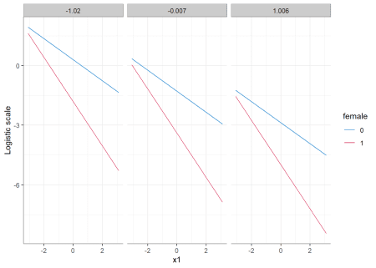

*Predictions from the model on the latent scale.*

emmeans(model, ~ x1 + female + x2,

at = list(x1 = c(-1, 1)),

cov.reduce = list(x2 = mean_sd)) %>%

contrast(interaction = c("pairwise", "pairwise"),

by = "x2")

## x2 = -1.020:

## x1_pairwise female_pairwise estimate SE df z.ratio p.value

## -1 - 1 0 - 1 -1.17 0.497 Inf -2.350 0.0188

##

## x2 = -0.007:

## x1_pairwise female_pairwise estimate SE df z.ratio p.value

## -1 - 1 0 - 1 -1.17 0.497 Inf -2.350 0.0188

##

## x2 = 1.006:

## x1_pairwise female_pairwise estimate SE df z.ratio p.value

## -1 - 1 0 - 1 -1.17 0.497 Inf -2.350 0.0188

##

## Note: contrasts are still on the log.o.r. scale

It seems that on the latent level the (estimated) difference of differences (the interaction) between female and x1 is unaffected by which level of x2 they are conditioned on. This makes sense – we did not model a 3-way interaction, so why should it? Everything is acting as expected.

Or is it? Well, that depends…

**2. On the response level (the delta method)**

We can also try and answer the same question on the response level using the delta method (baked into emmeans). Here we have two options for defining an “effect”:

1. An effect is a difference in probabilities.
2. An effect is a ratio of probabilities.

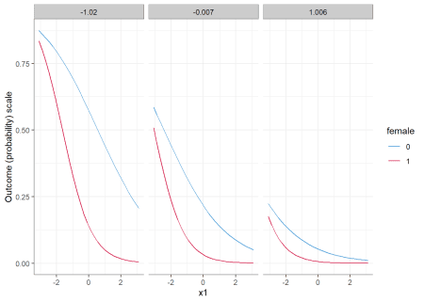

*Predictions from the model on the response scale.*

**2.1. Differences in probabilities**

For this, we just need to add trans = "response" in the call to emmeans():

emmeans(model, ~ x1 + female + x2,

at = list(x1 = c(-1, 1)),

cov.reduce = list(x2 = mean_sd),

trans = "response") %>%

contrast(interaction = c("pairwise", "pairwise"),

by = "x2")

## x2 = -1.020:

## x1_pairwise female_pairwise estimate SE df z.ratio p.value

## -1 - 1 0 - 1 -0.0265 0.0787 Inf -0.336 0.7365

##

## x2 = -0.007:

## x1_pairwise female_pairwise estimate SE df z.ratio p.value

## -1 - 1 0 - 1 0.0976 0.0470 Inf 2.075 0.0380

##

## x2 = 1.006:

## x1_pairwise female_pairwise estimate SE df z.ratio p.value

## -1 - 1 0 - 1 0.0371 0.0163 Inf 2.279 0.0227

# Difference of differences when x2 = -1.02

(0.69457 - 0.44178) - (0.32986 - 0.05059)

## [1] -0.02648

It seems that on the response level, we get different results than on the latent level. And not only that, but even though the model did not include a 3-way interaction, the 2-way female:x1 interaction is conditional on the level of x2 – changing in size as a function of x2, and is not significant in low levels of x2!

**2.2. Ratios of probabilities**

(Also called *risk ratios*.)

For this, we just need to add trans = "log" and type = "response" in the call to emmeans():

emmeans(model, ~ x1 + female + x2,

at = list(x1 = c(-1, 1)),

cov.reduce = list(x2 = mean_sd),

trans = "log",

type = "response") %>%

contrast(interaction = c("pairwise", "pairwise"),

by = "x2")

## x2 = -1.02:

## x1_pairwise female_pairwise ratio SE df z.ratio p.value

## -1 / 1 0 / 1 0.241 0.097 Inf -3.534 0.0004

##

## x2 = -0.007:

## x1_pairwise female_pairwise ratio SE df z.ratio p.value

## -1 / 1 0 / 1 0.268 0.124 Inf -2.856 0.0043

##

## x2 = 1.006:

## x1_pairwise female_pairwise ratio SE df z.ratio p.value

## -1 / 1 0 / 1 0.299 0.146 Inf -2.480 0.0131

##

## Tests are performed on the log scale

# Ratio of ratios when x2 = -1.02

(0.69457 / 0.44178) / (0.32986 / 0.05059)

## [1] 0.2411265

It seems that even on the response level, different delta methods produce different results![1](https://shouldbewriting.netlify.com/posts/2020-04-13-estimating-and-testing-glms-with-emmeans/#fn1) Although we maintain the finding that the size of the 2-way female:x1 interaction is conditional on the level of x2, here it *decreases* as a function of x2 (but is significant across all (tested) values of x2)!

(Note: as we are interested in the slope of x1, we could have used emtrends instead of emmeans. See code at the end of the post for what that would look like.)

**Not just a problem with interactions…**

As stated above, this is not only an issue of interactions. For example, when looking at the response level, the effect of x2 is itself conditional on the value of x2!

emmeans(model, ~ x2,

cov.reduce = list(x2 = mean_sd),

trans = "response") %>%

contrast(method = "consec")

## contrast estimate SE df z.ratio p.value

## -0.007 - -1.02 -0.2361 0.02190 Inf -10.782 <.0001

## 1.006 - -0.007 -0.0965 0.00825 Inf -11.695 <.0001

##

## Results are averaged over the levels of: female

## P value adjustment: mvt method for 2 tests

Note how the estimated effect of x2 is smaller for larger values of x2!

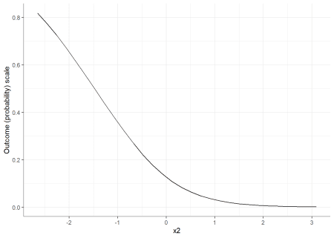

**Make the data and model**

set.seed(1678)

b0 <- -3.8 # Intercept

b1 <- .35 # X1 Effect

b2 <- .9 # X2 Effect

b3 <- 1.1 # Sex covariate effect

b13 <- .2 # product term coefficient

n <- 1000 # Sample Size

mu <- rep(0, 2) # Specify means

# Specify covariance matrix

S <- matrix(c(1, .5, .5, 1),

nrow = 2, ncol = 2)

sigma <- 1 # Level 1 error

# simulates our continuous predictors from a multivariate

# normal distribution

rawvars <- MASS::mvrnorm(n = n, mu = mu, Sigma = S)

cat <- rbinom(n = n, 1, .5)

id <- seq(1:n)

eij <- rep(rnorm(id, 0, sigma))

xb <- (b0) +

(b1) * (rawvars[, 1]) +

(b2) * (rawvars[, 2]) +

(b3) * cat +

b13 * cat * (rawvars[, 1]) +

eij

df <- data.frame(x1 = rawvars[, 1],

x2 = rawvars[, 2],

female = cat)

y <- plogis(xb) < 0.01

model <- glm(y ~ x1 * female + x2,

data = df,

family = "binomial")

**Using emtrends**

Note that the inferential results (\(z\) and \(p\) values) are similar (though not identical) to those obtained using emmeans.

# log(odds)

emtrends(model, ~ female + x2, "x1",

cov.reduce = list(x2 = mean_sd)) %>%

contrast(method = "pairwise", by = "x2")

## x2 = -1.020:

## contrast estimate SE df z.ratio p.value

## 0 - 1 0.584 0.248 Inf 2.350 0.0188

##

## x2 = -0.007:

## contrast estimate SE df z.ratio p.value

## 0 - 1 0.584 0.248 Inf 2.350 0.0188

##

## x2 = 1.006:

## contrast estimate SE df z.ratio p.value

## 0 - 1 0.584 0.248 Inf 2.350 0.0188

# diffs

emtrends(model, ~ female + x2, "x1",

cov.reduce = list(x2 = mean_sd),

trans = "response") %>%

contrast(method = "pairwise", by = "x2")

## x2 = -1.020:

## contrast estimate SE df z.ratio p.value

## 0 - 1 0.0107 0.04117 Inf 0.259 0.7957

##

## x2 = -0.007:

## contrast estimate SE df z.ratio p.value

## 0 - 1 -0.0542 0.02399 Inf -2.259 0.0239

##

## x2 = 1.006:

## contrast estimate SE df z.ratio p.value

## 0 - 1 -0.0195 0.00793 Inf -2.457 0.0140

# ratios

emtrends(model, ~ female + x2, "x1",

cov.reduce = list(x2 = mean_sd),

trans = "log", type = "response") %>%

contrast(method = "pairwise", by = "x2")

## x2 = -1.020:

## contrast estimate SE df z.ratio p.value

## 0 - 1 0.727 0.207 Inf 3.509 0.0004

##

## x2 = -0.007:

## contrast estimate SE df z.ratio p.value

## 0 - 1 0.663 0.233 Inf 2.848 0.0044

##

## x2 = 1.006:

## contrast estimate SE df z.ratio p.value

## 0 - 1 0.605 0.244 Inf 2.476 0.0133

**Conclusion**

The growing popularity of GLMs (and GLMMs) in social research seems to come with another source of researcher degrees of freedom